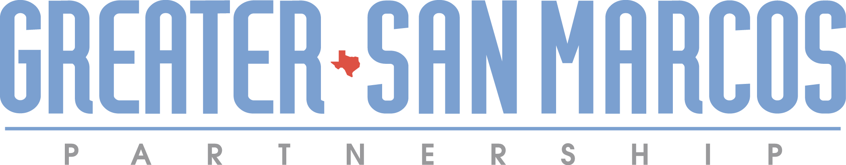

The Greater San Marcos Partnership (GSMP), the economic development organization serving the City of San Marcos and the communities within Hays and Caldwell Counties, focuses on the attraction of high quality jobs and investment to the region.

**Job Title: Project Manager**

**Reports to: Director of Business Development**

**SUMMARY:** GSMP is seeking an enthusiastic and highly-organized project manager to provide support in a fast-paced environment with high visibility and interaction with regional business leaders. In this role, you will be a community engagement enthusiast, a data and idea catalyst, and a collaborative change agent. You will be at the forefront of our business attraction team preparing responses for projects through multiple mediums, connecting with partners regarding necessary data, and helping shape the future of this innovative region.

**Key Responsibilities:**

* Receives incoming inquiries and requests from clients, site selection consultants, partners, and other lead sources and prepares responses to RFIs, aggregating necessary data and site information, in coordination with research analyst and other partners as necessary.
* Handles sensitive documentation/information and maintains confidentiality at all times.
  + Helps conduct site visits with companies
  + Prepares administrative reports, development of SOPs, and assists with program area functions, operations and with the development of plans to initiate and address areas of concern.
* Maintains pipeline database and regularly updates project status through internal CRM
* Creates reports in CRM to reflect pipeline status, trends, and other key data points
* Maintain pipeline of available sites through relationships with brokers and developers
* Conducting impact analyses consistent with regional incentive policies and recommending incentive packages, presenting projects and proposals to elected officials and city/county staff
* Managing client follow-up and ongoing project related communications
* Working closely with regional economic development partners in Hays and Caldwell Counties

**Requirements:**

* + Bachelor’s degree in Business, Economics, Political Science or related field.
  + Working knowledge of industrial, demographic, infrastructure, government, and quality of life issues as they relate to business decisions for location and expansion.
* Ability to be resourceful and proactive when issues arise.
* Highly organized with strict quality control. Able to multitask and manage time wisely skills ability to prioritize tasks.
* Excellent computer skills including MS Office (Word, Excel, Power Point) and willingness to learn new platforms. Ability or experience with databases.
* Able to work independently, meet deadlines and handle multiple projects.

**Please submit letter of interest and resume to jobs@greatersanmarcostx.com.**